Practical 03

Q1 – Map (Region-wise Sales Distribution): Write an SQL query to calculate total sales by REGION_NAME and visualize the geographic distribution using a Map.
SELECT
g.REGION_NAME,
SUM(f.SALES) AS TOTAL_SALES
FROM AV.SALES_FACT f
JOIN AV.GEOGRAPHY_DIM g
ON f.STATE_PROVINCE_ID = g.STATE_PROVINCE_ID
GROUP BY g.REGION_NAME;
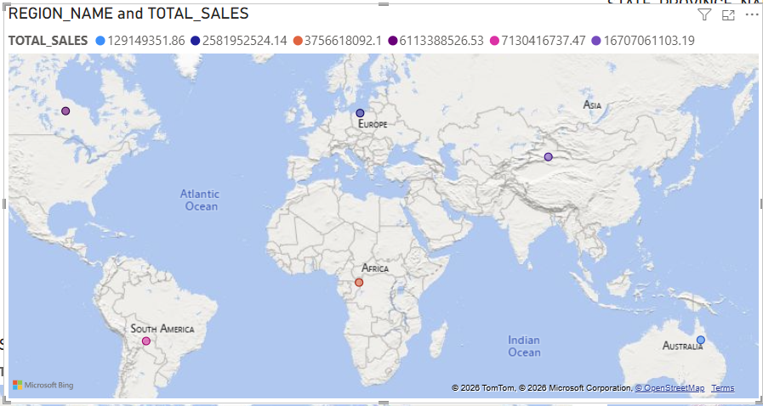

Q2 – Map (Province-wise Units Sold): Write an SQL query to compute total units sold by STATE_PROVINCE_NAME and display the spatial volume distribution using a Map.
SELECT
g.STATE_PROVINCE_NAME,
SUM(f.UNITS) AS TOTAL_UNITS
FROM AV.SALES_FACT f
JOIN AV.GEOGRAPHY_DIM g
ON f.STATE_PROVINCE_ID = g.STATE_PROVINCE_ID
GROUP BY g.STATE_PROVINCE_NAME;
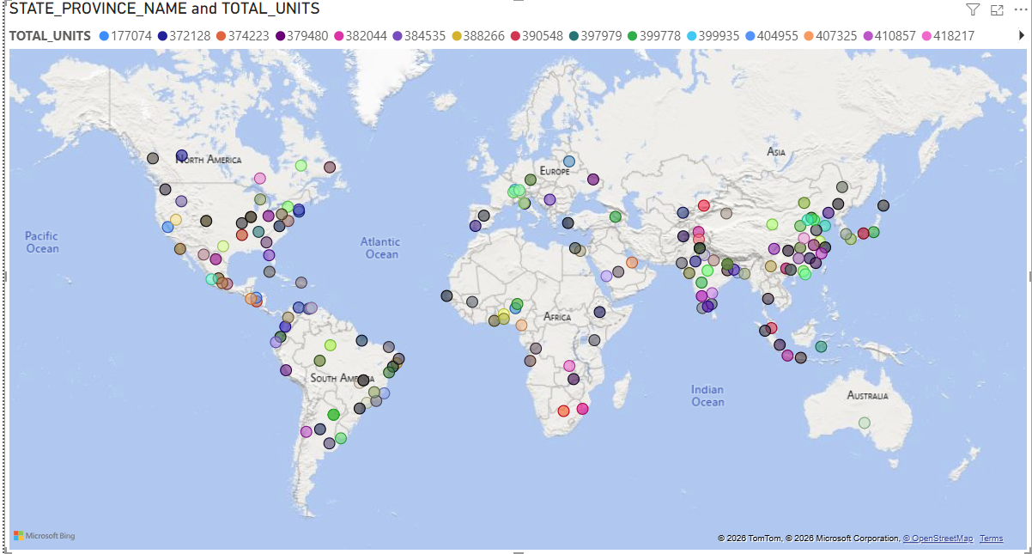

Q3 – Filled Map (Province Sales Intensity): Write an SQL query to calculate total sales for each STATE_PROVINCE_NAME and visualize sales intensity variations using a Filled Map.
SELECT
g.STATE_PROVINCE_NAME,
SUM(f.SALES) AS TOTAL_SALES
FROM AV.SALES_FACT f
JOIN AV.GEOGRAPHY_DIM g
ON f.STATE_PROVINCE_ID = g.STATE_PROVINCE_ID
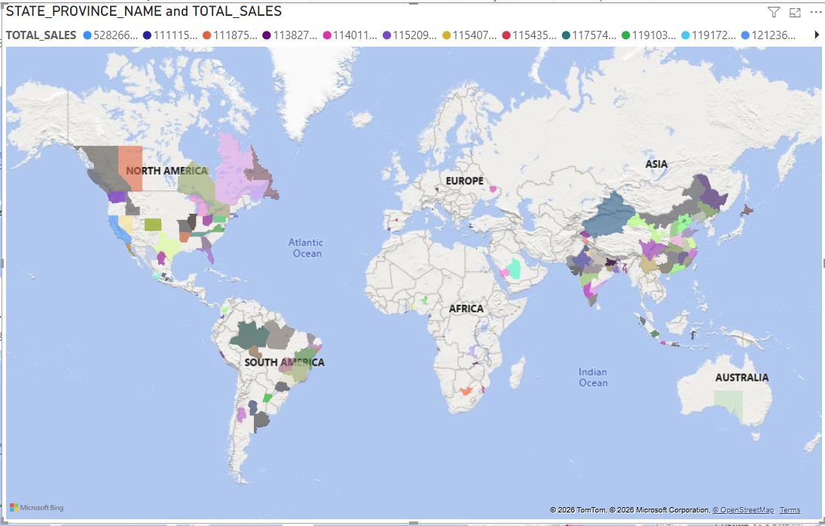
GROUP BY g.STATE_PROVINCE_NAME;

Q4 – Filled Map (Province Contribution Percentage): Write an SQL query to compute each province’s percentage contribution to overall sales and display relative importance using a Filled Map.
SELECT
g.STATE_PROVINCE_NAME,
SUM(f.SALES) AS PROVINCE_SALES,
SUM(f.SALES) * 100.0 /
(SELECT SUM(SALES) FROM AV.SALES_FACT) AS SALES_PERCENTAGE
FROM AV.SALES_FACT f
JOIN AV.GEOGRAPHY_DIM g
ON f.STATE_PROVINCE_ID = g.STATE_PROVINCE_ID
GROUP BY g.STATE_PROVINCE_NAME;
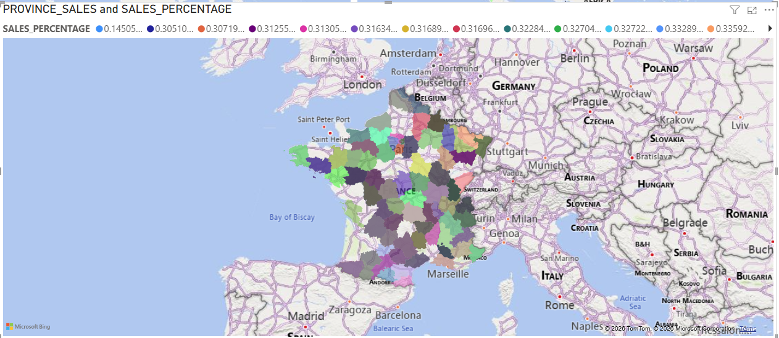

Q5 – Filled Map (Year-over-Year Province Growth): Write an SQL query to calculate year-over-year sales growth by province and visualize growth patterns using a Filled Map.
SELECT
STATE_PROVINCE_NAME,
SALES_YEAR,
YEARLY_SALES,
YEARLY_SALES
- LAG(YEARLY_SALES)
OVER (PARTITION BY STATE_PROVINCE_NAME ORDER BY SALES_YEAR)
AS YOY_GROWTH
FROM (
SELECT
g.STATE_PROVINCE_NAME,
SUBSTR(f.MONTH_ID, 1, 4) AS SALES_YEAR,
SUM(f.SALES) AS YEARLY_SALES
FROM AV.SALES_FACT f
JOIN AV.GEOGRAPHY_DIM g
ON f.STATE_PROVINCE_ID = g.STATE_PROVINCE_ID
GROUP BY g.STATE_PROVINCE_NAME, SUBSTR(f.MONTH_ID, 1, 4)
) s;
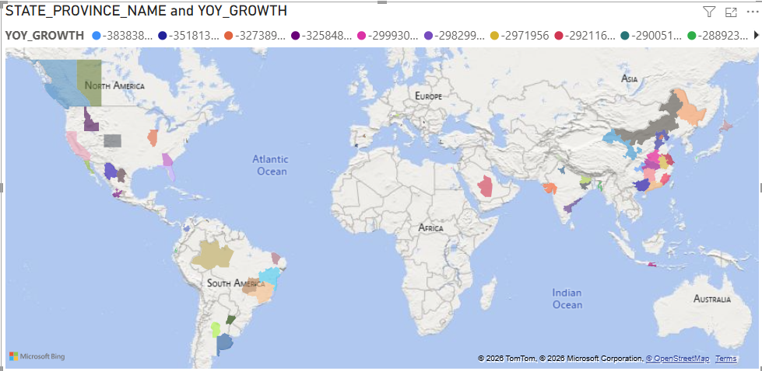
Q6 – Shape Map (Category Dominance by Province): Write an SQL query to identify the highest-selling CATEGORY_NAME in each STATE_PROVINCE_NAME and visualize dominance using a Shape Map.
SELECT
STATE_PROVINCE_NAME,
CATEGORY_NAME,
TOTAL_SALES
FROM (
SELECT
g.STATE_PROVINCE_NAME,
p.CATEGORY_NAME,
SUM(f.SALES) AS TOTAL_SALES,
RANK() OVER (
PARTITION BY g.STATE_PROVINCE_NAME
ORDER BY SUM(f.SALES) DESC
) AS RNK
FROM AV.SALES_FACT f
JOIN AV.GEOGRAPHY_DIM g
ON f.STATE_PROVINCE_ID = g.STATE_PROVINCE_ID
JOIN AV.PRODUCT_DIM p
ON f.CATEGORY_ID = p.CATEGORY_ID
GROUP BY g.STATE_PROVINCE_NAME, p.CATEGORY_NAME
) x
WHERE RNK = 1;
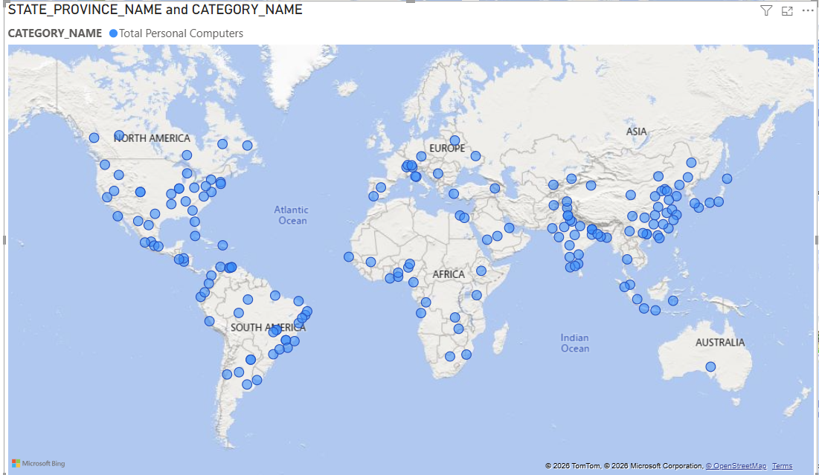
Q7 – Shape Map (Province Performance Classification): Write an SQL query to classify provinces into high, medium, and low sales groups based on total sales and visualize classification using a Shape Map.
SELECT
g.STATE_PROVINCE_NAME,
SUM(f.SALES) AS TOTAL_SALES,
CASE
WHEN SUM(f.SALES) >= 1000000 THEN 'High'
WHEN SUM(f.SALES) >= 500000 THEN 'Medium'
ELSE 'Low'
END AS PERFORMANCE_LEVEL
FROM AV.SALES_FACT f
JOIN AV.GEOGRAPHY_DIM g
ON f.STATE_PROVINCE_ID = g.STATE_PROVINCE_ID
GROUP BY g.STATE_PROVINCE_NAME;
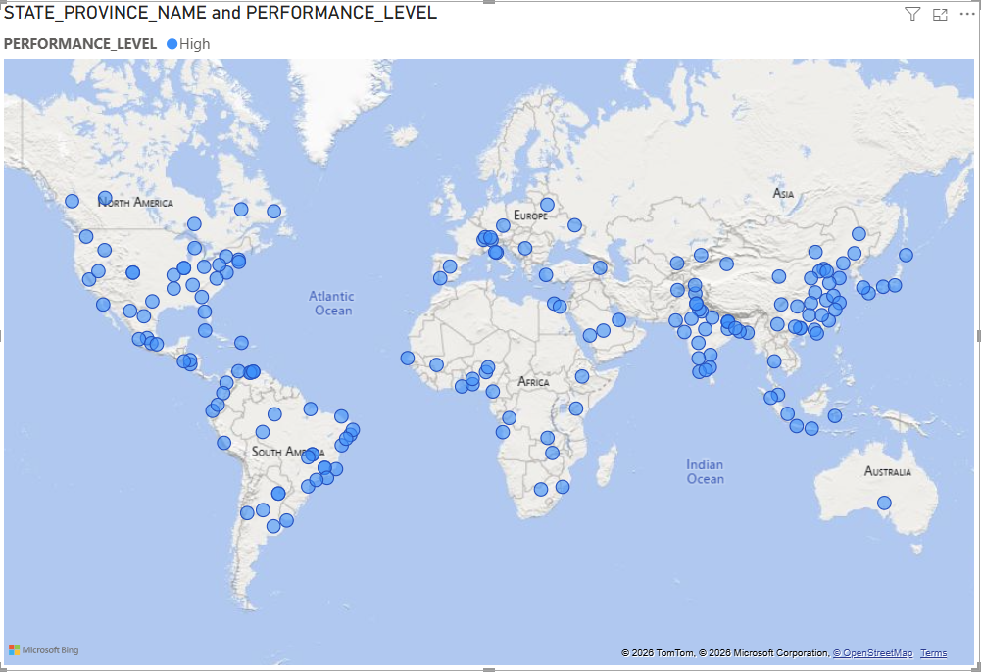
Q8 – Shape Map (Province Average Selling Price): Write an SQL query to calculate average selling price (sales per unit) by province and visualize pricing behavior using a Shape Map.
SELECT
g.STATE_PROVINCE_NAME,
SUM(f.SALES) / NULLIF(SUM(f.UNITS), 0) AS AVG_SELLING_PRICE
FROM AV.SALES_FACT f
JOIN AV.GEOGRAPHY_DIM g
ON f.STATE_PROVINCE_ID = g.STATE_PROVINCE_ID
GROUP BY g.STATE_PROVINCE_NAME;
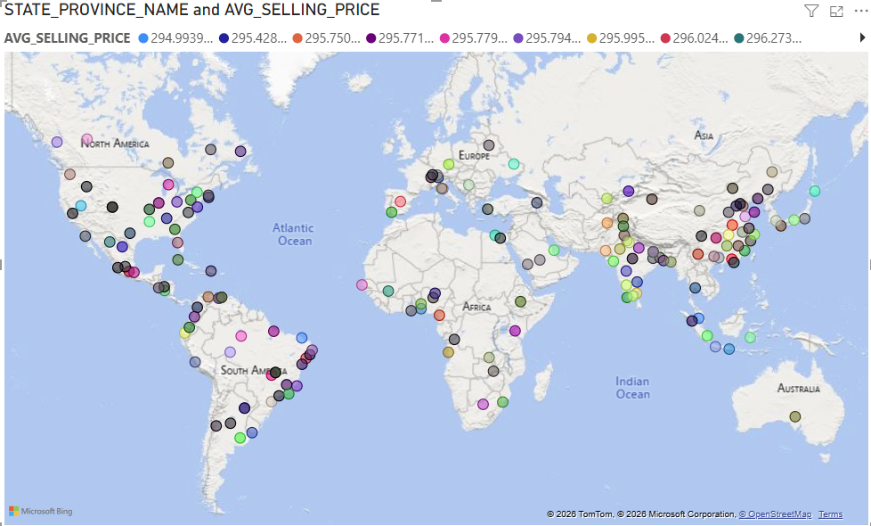

Q9 – Azure Maps (Monthly Sales Hotspots): Write an SQL query to calculate monthly sales by province and visualize temporal sales hotspots using Azure Maps.
SELECT
g.STATE_PROVINCE_NAME,
f.MONTH_ID,
SUM(f.SALES) AS MONTHLY_SALES
FROM AV.SALES_FACT f
JOIN AV.GEOGRAPHY_DIM g
ON f.STATE_PROVINCE_ID = g.STATE_PROVINCE_ID
GROUP BY g.STATE_PROVINCE_NAME, f.MONTH_ID;

Q10 – Azure Maps (Regional Sales Volatility): Write an SQL query to compute sales variability over time for each region and visualize stability versus volatility using Azure Maps.
SELECT
REGION_NAME,
STDDEV(MONTHLY_SALES) AS SALES_VOLATILITY
FROM (
SELECT
g.REGION_NAME,
f.MONTH_ID,
SUM(f.SALES) AS MONTHLY_SALES
FROM AV.SALES_FACT f
JOIN AV.GEOGRAPHY_DIM g
ON f.STATE_PROVINCE_ID = g.STATE_PROVINCE_ID
GROUP BY g.REGION_NAME, f.MONTH_ID
) s
GROUP BY REGION_NAME;

Q11 – Table (Detailed Sales Summary): Write an SQL query to display YEAR_NAME, MONTH_LONG_NAME, REGION_NAME, CATEGORY_NAME, total sales, and total units in a Table.
SELECT
SUBSTR(f.MONTH_ID, 1, 4) AS YEAR,
f.MONTH_ID,
g.REGION_NAME,
p.CATEGORY_NAME,
SUM(f.SALES) AS TOTAL_SALES,
SUM(f.UNITS) AS TOTAL_UNITS
FROM AV.SALES_FACT f
JOIN AV.GEOGRAPHY_DIM g
ON f.STATE_PROVINCE_ID = g.STATE_PROVINCE_ID
JOIN AV.PRODUCT_DIM p
ON f.CATEGORY_ID = p.CATEGORY_ID
GROUP BY
SUBSTR(f.MONTH_ID, 1, 4),
f.MONTH_ID,
g.REGION_NAME,
p.CATEGORY_NAME
ORDER BY YEAR, f.MONTH_ID;
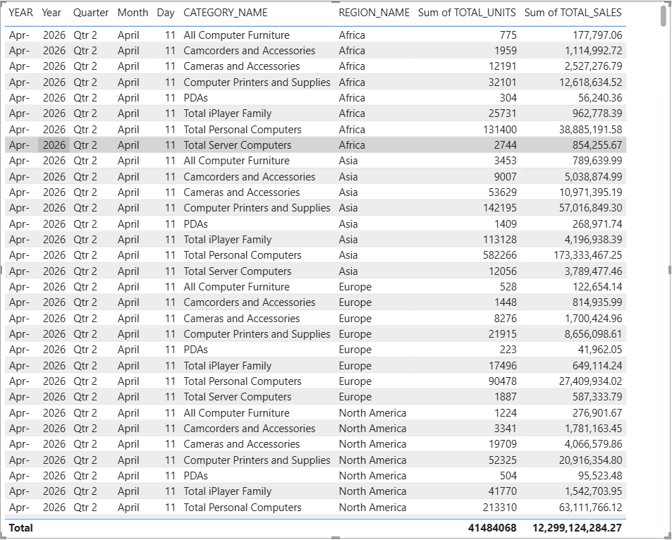

Q12 – Table (Category Consistency Analysis): Write an SQL query to calculate average monthly sales and sales variance for each CATEGORY_NAME and present results in a Table.
SELECT
CATEGORY_NAME,
AVG(MONTHLY_SALES) AS AVG_MONTHLY_SALES,
VARIANCE(MONTHLY_SALES) AS SALES_VARIANCE
FROM (
SELECT
p.CATEGORY_NAME,
f.MONTH_ID,
SUM(f.SALES) AS MONTHLY_SALES
FROM AV.SALES_FACT f
JOIN AV.PRODUCT_DIM p
ON f.CATEGORY_ID = p.CATEGORY_ID
GROUP BY p.CATEGORY_NAME, f.MONTH_ID
) s
GROUP BY CATEGORY_NAME;
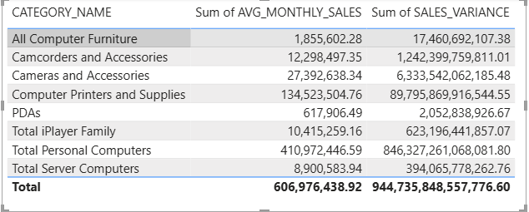

Q13 – Matrix (Region × Category Sales): Write an SQL query to compute total sales by REGION_NAME and CATEGORY_NAME and analyze cross-dimensional performance using a Matrix.
SELECT
g.REGION_NAME,
p.CATEGORY_NAME,
SUM(f.SALES) AS TOTAL_SALES
FROM AV.SALES_FACT f
JOIN AV.GEOGRAPHY_DIM g
ON f.STATE_PROVINCE_ID = g.STATE_PROVINCE_ID
JOIN AV.PRODUCT_DIM p
ON f.CATEGORY_ID = p.CATEGORY_ID
GROUP BY g.REGION_NAME, p.CATEGORY_NAME;
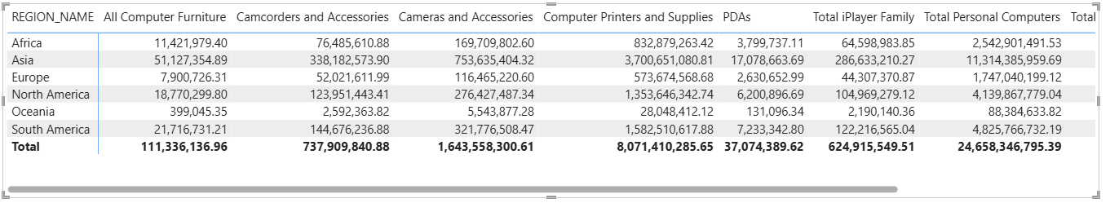

Q14 – Matrix (Month × Category Trend): Write an SQL query to calculate monthly sales by
CATEGORY_NAME and analyze temporal trends using a Matrix.
SELECT
f.MONTH_ID,
p.CATEGORY_NAME,
SUM(f.SALES) AS MONTHLY_SALES
FROM AV.SALES_FACT f
JOIN AV.PRODUCT_DIM p
ON f.CATEGORY_ID = p.CATEGORY_ID
GROUP BY f.MONTH_ID, p.CATEGORY_NAME
ORDER BY f.MONTH_ID;

Q15 – Card (Total Sales Indicator): Write an SQL query to calculate overall total sales and display the value using a Card.
SELECT
SUM(SALES) AS TOTAL_SALES
FROM AV.SALES_FACT;
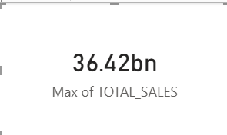

Q16 – Card (Total Units Indicator): Write an SQL query to calculate overall total units sold and display the value using a Card.
SELECT
SUM(UNITS) AS TOTAL_UNITS
FROM AV.SALES_FACT;
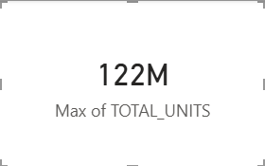

Q17 – Multi-row Card (Key Business Metrics): Write an SQL query to calculate total sales, total units, average selling price, and number of distinct categories and present them using a Multi-row Card.
SELECT
SUM(SALES) AS TOTAL_SALES,
SUM(UNITS) AS TOTAL_UNITS,
SUM(SALES) / NULLIF(SUM(UNITS), 0) AS AVG_SELLING_PRICE,
COUNT(DISTINCT CATEGORY_ID) AS TOTAL_CATEGORIES
FROM AV.SALES_FACT;
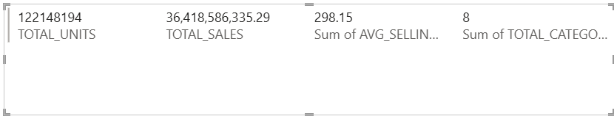

Q18 – Multi-row Card (Regional Snapshot): Write an SQL query to calculate region-wise sales, units, and sales contribution percentage and present them using a Multi-row Card.
SELECT
g.REGION_NAME,
SUM(f.SALES) AS REGION_SALES,
SUM(f.UNITS) AS REGION_UNITS,
SUM(f.SALES) * 100.0 /
(SELECT SUM(SALES) FROM AV.SALES_FACT) AS SALES_PERCENTAGE
FROM AV.SALES_FACT f
JOIN AV.GEOGRAPHY_DIM g
ON f.STATE_PROVINCE_ID = g.STATE_PROVINCE_ID
GROUP BY g.REGION_NAME;
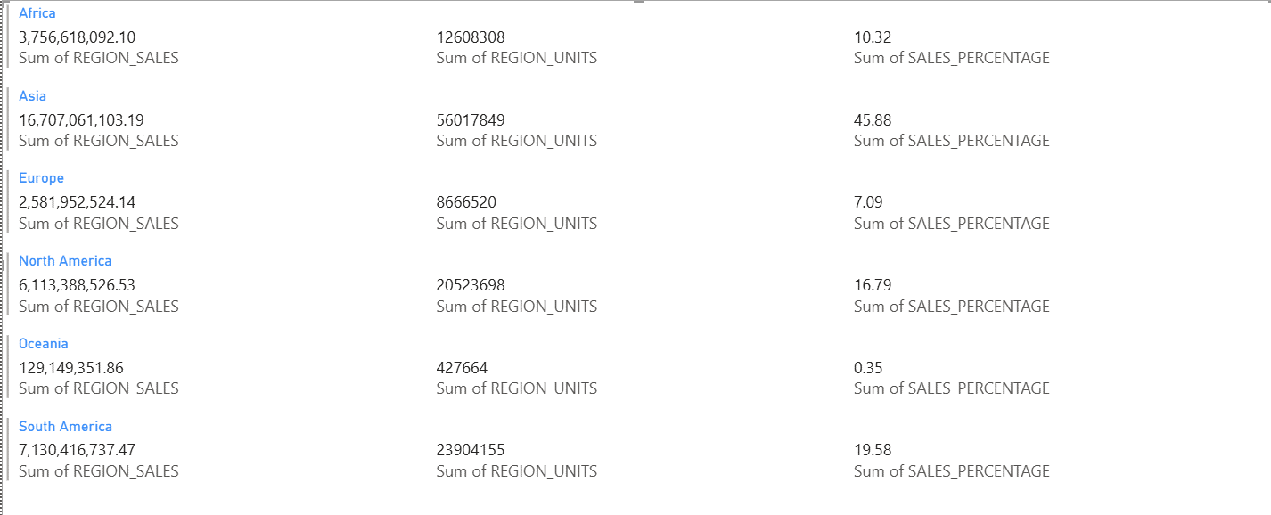

Q19 – KPI (Month-over-Month Sales Growth): Write an SQL query to calculate current month sales, previous month sales, and growth rate and visualize performance using a KPI.
SELECT
MONTH_ID,
MONTHLY_SALES,
MONTHLY_SALES -
LAG(MONTHLY_SALES) OVER (ORDER BY MONTH_ID) AS MOM_GROWTH
FROM (
SELECT
MONTH_ID,
SUM(SALES) AS MONTHLY_SALES
FROM AV.SALES_FACT
GROUP BY MONTH_ID
) s;

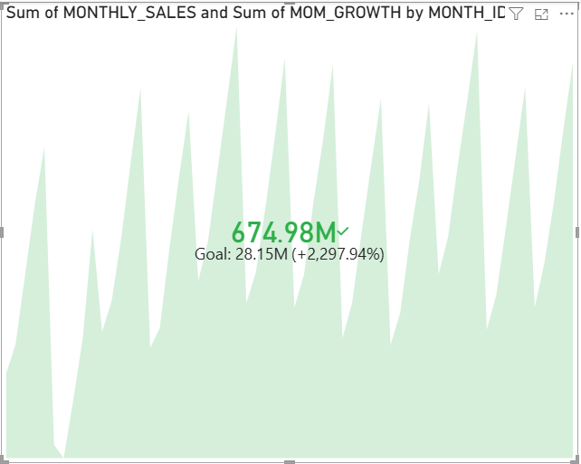

Q20 – Gauge (Sales vs Historical Benchmark): Write an SQL query to compare current month sales against the historical average monthly sales and visualize performance using a Gauge.
SELECT
(SELECT SUM(SALES)
FROM AV.SALES_FACT
WHERE MONTH_ID = (SELECT MAX(MONTH_ID) FROM AV.SALES_FACT)
) AS CURRENT_MONTH_SALES,

(SELECT AVG(MONTHLY_SALES)
FROM (
SELECT MONTH_ID, SUM(SALES) AS MONTHLY_SALES
FROM AV.SALES_FACT
GROUP BY MONTH_ID
)
) AS HISTORICAL_AVG_SALES
FROM DUAL;
